The Islamia University of Bahawalpur
Department of INFORMATION TECHNOLOGY

FINAL YEAR PROJECT REPORT
(FYP Report)
for
Attendance Desk
Project Attendance Management System
Version 1.0
By
Name | Roll Number
NOOR FATIMA | F23BINFT1M01028

Session [2023 – 2027]
Supervisor
SHAHRUKH ALI ZAI
Bachelor of Science in
INFORMATION TECHNOLOGY
Table of Contents
1. Project Overview 4
2. Project Aim 4
3. Core Features 4
4. Technical Stack 4
5. Setup and Execution 5
6. Usage 6
6.1 Roles and Permissions 6
6.2 Manager 6
6.3 Member 7
6.4 Admin 7
7. Limitations 8
8. Upcoming Improvements 8
9. Conclusion 8

1. Project Overview
Attendance Desk is a web-based project attendance management system. Project managers open an attendance session, team members check in on site with a session code (or QR code) and their location, and the system turns the records into dashboards, reports and CSV exports.
The system replaces paper sheets, chat messages and shared spreadsheets, which are slow to collect, easy to falsify and hard to total. It keeps one record per member per session and calculates attendance rates automatically.
Full details are in the Software Requirements Specification (SRS) and the Software Design Document (SDD) delivered with this report.

2. Project Aim
- Give projects a reliable, tamper-resistant record of who attended and when.
- Prove presence on site by combining a session code with a location check.
- Give managers control: open and close sessions, correct records by hand.
- Give managers, administrators and members clear views of attendance and exportable reports.

3. Core Features
- Roles: Admin, Manager and Member, each with its own screens and permissions.
- Projects and sites: each project has a site position, a check-in radius (20 to 2000 m) and a grace period (default 15 minutes).
- Sessions: open, close and reopen; unique code such as MTF-9499 with a QR image.
- Check-in: session code plus location; status is Present or Late automatically.
- Manual marking: Present, Late, Absent or Excused, with a bulk action and clear option.
- Dashboard and reports: indicators, daily rate chart, attention list, summary table, daily log matrix.
- CSV export: summary and detailed logs.
- My attendance: every member sees their own rate, counts and history.
- Audit log: every change is recorded (target system).

Attendance rate
Rate = (Present + Late) / (Present + Late + Absent). Excused and not-marked sessions are left out. Members below 80% are flagged for attention.

4. Technical Stack
Table 1: Technology stack
Area | Target system | Prototype
Front end | React single-page app | React 18 (single HTML file)
Back end | Node.js with Express REST API | Not included
Database | PostgreSQL | Browser local storage (sample data)
Security | JWT, bcrypt, HTTPS, role checks, audit log | User switcher in place of login
Location | Browser Geolocation API, haversine distance | Distance slider simulates position
QR code | qrcode library | qrcode-generator library

Architecture
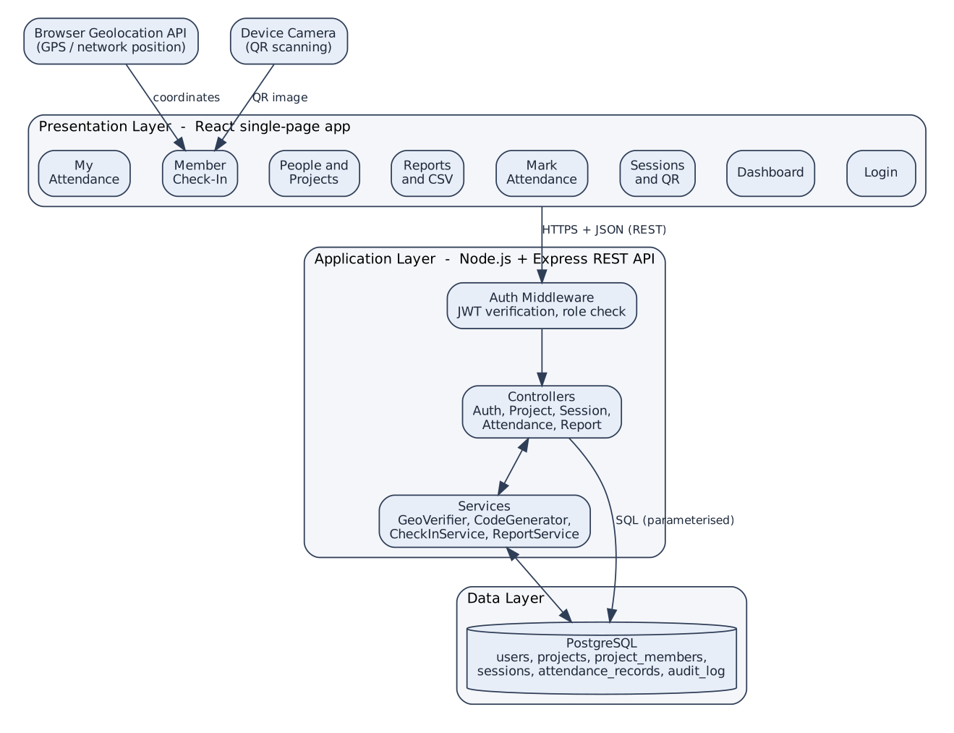
Figure 1: System architecture

5. Setup and Execution
Current status: the delivered code is a working front-end prototype that demonstrates every screen and rule with sample data. The Node.js and PostgreSQL back end is designed in the SDD but not yet implemented.

Run the prototype
- Open the published prototype link, or open attendance-desk.html in a modern browser (internet is needed to load the React and QR libraries).
- Choose a user from the user menu at the top right (Admin, Manager or Member).
- Use the tabs to try the features. Data is kept in the browser and can be reset by clearing site data.

Build the full system (planned)
- Create a PostgreSQL database and run the schema from the SDD data dictionary.
- Set environment variables: database URL, token secret, token lifetime.
- Install and start the API: npm install then npm start.
- Build the React app (npm run build) and serve it from the API.
- Create the first Admin user, then projects, members and sessions.

6. Usage

6.1 Roles and Permissions
Table 2: Roles and permissions
Capability | Admin | Manager | Member
Manage users, projects, memberships | Yes | No | No
Open, close, reopen sessions | Yes | Own projects | No
Mark attendance by hand | Yes | Own projects | No
Dashboard, reports, CSV | All projects | Own projects | No
Check in | No | No | Yes
View own attendance | No | No | Yes

6.2 Manager
- Open Sessions, choose the project, date and start time, and select Open session.
- Show the QR or read out the code to the team.
- Open Mark attendance to review the roster and correct statuses.
- Close the session when finished.
- Use Reports to see rates and export CSV.
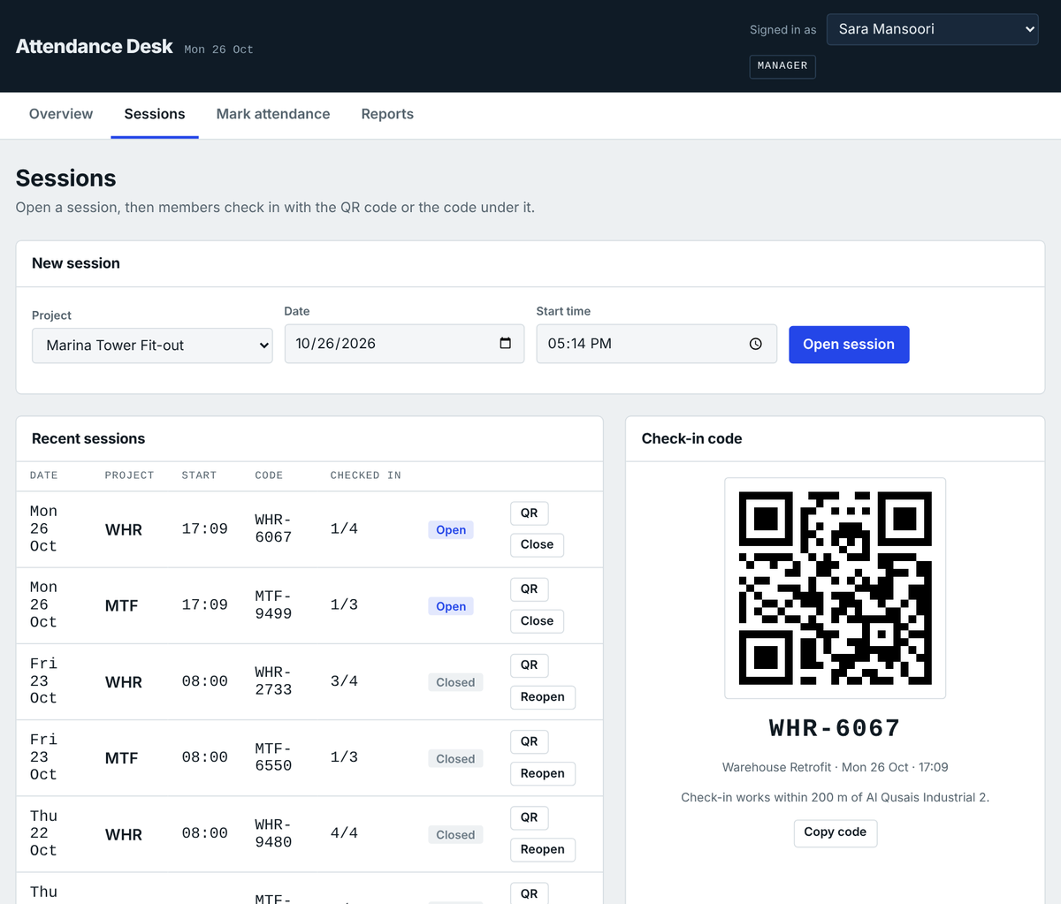
Figure 2: Sessions screen

6.3 Member
- Open Check In and pick today’s session.
- Enter the session code and allow location access.
- Select Check in and read the confirmation (Present or Late).
- Open My attendance to see the personal record.
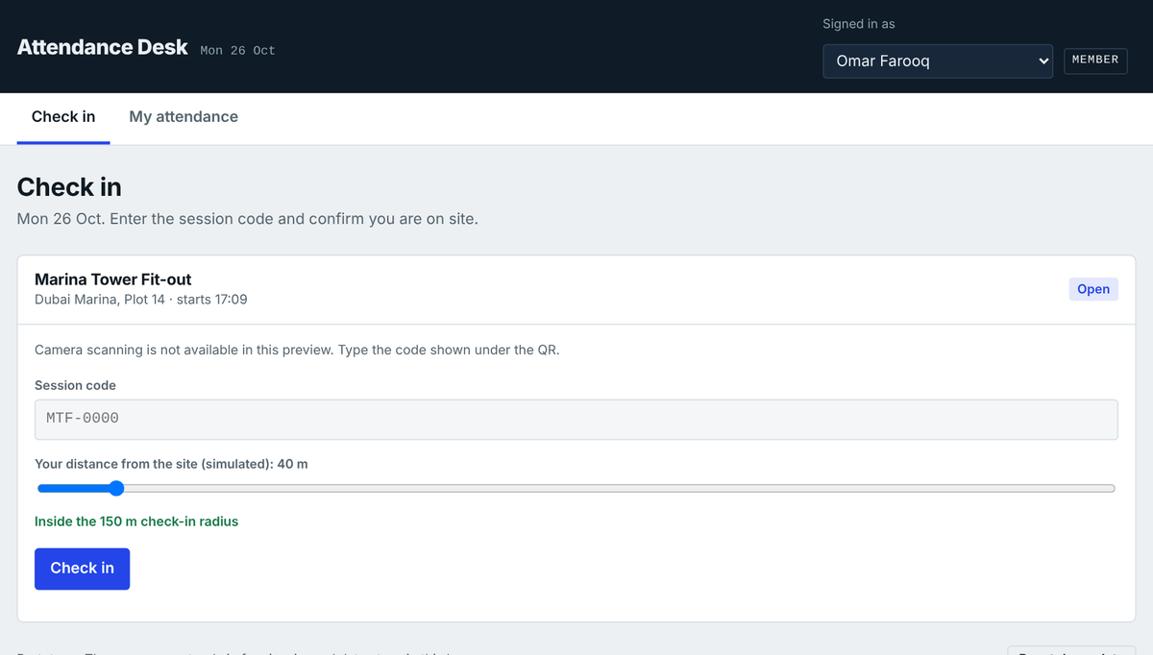
Figure 3: Member check-in screen

6.4 Admin
- Open People and projects.
- Add a project with its site position, radius and grace period.
- Add people and tick the projects each member belongs to.
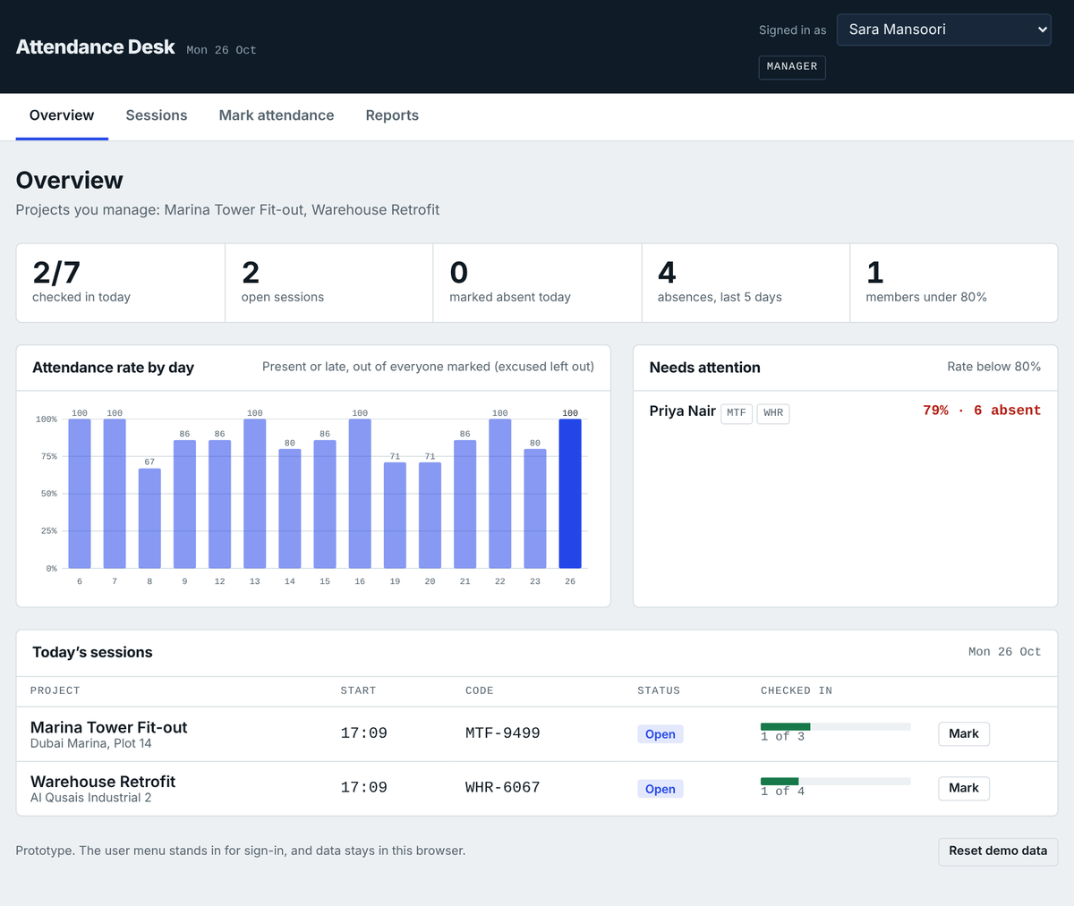
Figure 4: Overview screen

7. Limitations
- The prototype has no real login, back end or shared database; data stays in one browser.
- Location and camera access are simulated or unavailable in the hosted prototype page.
- GPS accuracy varies indoors, so the radius should allow for it; location alone cannot prove identity.
- The session code can be shared with someone off site; the radius check limits, but does not remove, this risk.
- No offline check-in, notifications or payroll integration yet.

8. Upcoming Improvements
- Implement the Node.js and PostgreSQL back end and real authentication (Sprints 1 to 5).
- Use rotating QR codes and device checks to reduce code sharing.
- Offline check-in that syncs when the connection returns.
- Email or push reminders and late-arrival alerts.
- PDF reports and charts per member.
- Leave management and integration with payroll or HR systems.

9. Conclusion
Attendance Desk shows how a small, role-based web system can make project attendance reliable and easy to report. The requirements, design and prototype are complete; the next step is the full back end.

